Laura Austin, Principal
austinlk@santarosa.k12.fl.us
www.santarosaonline.org
850. 981.7860, ex. 101

Creating an FLVS Account

If you have previously created an FLVS profile, STOP, do not create second one. Contact Laura Austin at the email/phone number above for login information.

Creating an FLVS Account

- Go to www.flvs.net and choose “Enroll” on top navigation bar.
- Choose “County Virtual School”
- Choose “Enroll in 6 – 12”
- Choose “New Students Start Here” and select “I live in Florida” from the dropdown menu.
- Choose “Santa Rosa” for county, “Public/Charter School Student” for student type, then click “Continue.”
- On “Refine Your Search” page, place cursor on backpack icon in upper right corner and left click.
- Select “Continue.” (You will add courses later.)
- Select “Create My Account,” fill in Personal Information, then select “Sign Up.”
- Fill in the other information under “Personal Information.”
- Under “Physical School,” select the appropriate grade level and make sure the county is “Santa Rosa.”
- Enter ten digit student ID(#57)
- Under “School Name,” choose your school. Under “School Counselor,” choose your guidance counselor.
- Complete the information under “Address” and “Telephone” and select “Next.”
- Have your parent complete “Parent/Guardian Information” and select “Next.”
- Complete “Race” and “Ethnicity” and select “Next.”
- Student and Parent should click “I agree” under “Commitments” and then select “Submit.”

Requesting Courses

- Login into your FLVS account and select “Request New Courses” from the top navigation bar.
- Verify that your student information is correct and select “Save and Continue.”
- Select “Browse Course Catalog” then refine your search by selecting the appropriate boxes on the left. For instance, if you are a high school student wanting to take Algebra 1, check the appropriate level under “High School” and check “Mathematics” under “Subject.”
- Select the course you want to take and then the following:

1) Select one or both segments, according to instructions from your school counselor.
2) Choose your preferred start date of ___________________( date given by counselor).
3) If you want a local Santa Rosa County teacher and your school counselor to have full access to your course
should you have problems, under “Course Availability, choose “Select a District Franchise” and then “Santa
Rosa Online” so that you end up with a green check on the right (see below).

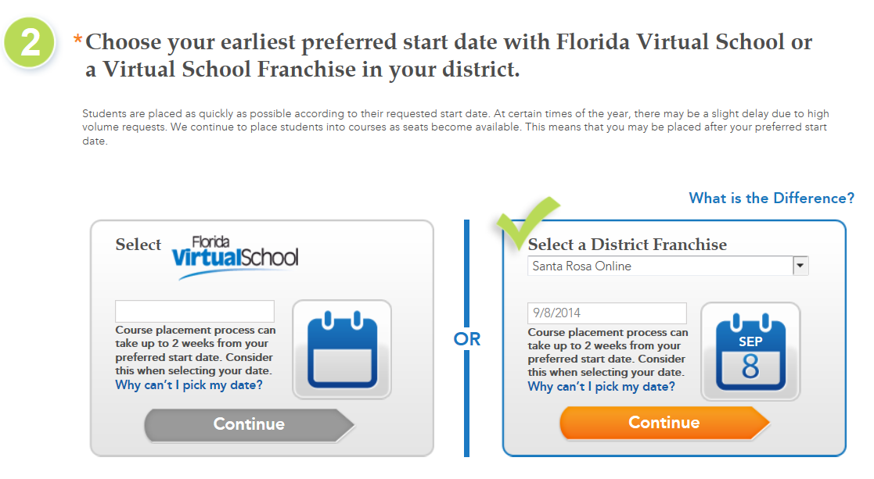

- Once you have chosen Santa Rosa Online and the date, press “Add to Backpack.”

- At that point, you can request additional courses or logout. ALL STUDENTS and PARENTS should be sure to watch “FLVS Quick Start: New Student Orientation” (link found on the student dashboard when you login to FLVS) before the student begins virtual classes.

